**Computer Networks**

BSSE 5-B



**Submitted By:**

Ali Taimur (SU92-BSSEM-F22-082)

**Project Title:**

**“Secure Company Network”**

Table of Contents

* **Introduction**
* **Objective**   **.**
* **Scope ………………………………………………………………………..**5
* **Network Scenario ……………………………………..………………..….**4
* **Topology Diagram …………………………………………………………**6
* **Conclusion ………………………………………………………………….**7
* **References** …………………………………………………………………..8

# **Introduction: -**

The **Secure Company Network**, referred to as SCN, is an application that will help users better utilize rooms used by UP employees and other guests. SCN helps users manage guest flows by affording them the ability to easily check UP guests in, check them out, and generate stay reports, among other things.

# **Objective: -**

The project, Secure Company Network is a cisco-based application that allows the hotel manager to handle all hotel activities. The ability to manage various hotel bookings and rooms make this system very flexible and convenient. Hotel management project provides room booking, staff management and other necessary hotel management features. The system is hence useful for both customers and managers to portable manage the hotel activities.

**Project Scope: -**

The Secure Company Network is one of the most important components of the wider service industry, catering for customers who require overnight accommodation. It is closely associated with the travel industry and the hospitality industry, although there are notable differences in scope. This is very helpful for the upcoming projects.

**Network Scenario: -**

In this project we use 4 routers 2 multi-layer switch and several Switches and PC and IP Phone and 5 printers and 3 servers inside for company uses company and 5 outside connected with firewall.

* **Offices:**
  + We make 5 offices areas 1 server area. Which consists of different PC's server and all are connected through switch (2950-24).
* **Security:**
  + We have two firewalls for security purposes. It saves system from any unauthorized access.
* **Server:**
  + We have a server area which consists of 3 servers and PC and connected through switch (2950-24).
* **Other:**
  + These all switches connected to each other with the help of routers, and which connects the whole networks configuration of the hotel.
* **DNS & DHCP:**
* Domain Name System (DNS) is an Internet service that translates domain names into IP addresses. Dynamic Host Configuration Protocol (DHCP) is a protocol for automatically assigning IP addresses and other configurations to devices when they connect to a network.
* **Cloud Router:**
* One switch and one router grouped together to provide any combination of hardware redundancy, service redundancy, load balancing and increased speed.

**Topology Diagram: -**

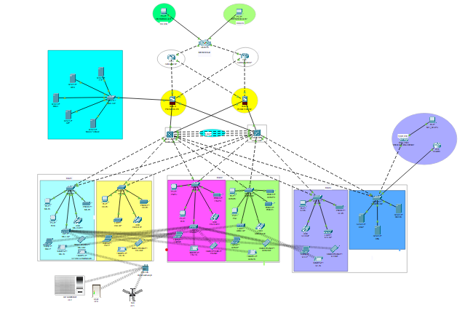

**Conclusion: -**

The conclusion of this project is A Secure Company Network is a computerized management system. This system share enables us to communicate within and outside the company of this organization.

We used hybrid topology in this network

**Reference:**

* Take some useful information from the internet related to our project.
* https://youtu.be/yYM-fVQNM_A?si=HL5iN_6ClBBYhMnK